**AMERICAN INTERNATIONAL**

**UNIVERSITY-BANGLADESH**

408/1, Kuratoli, Khilkhet, Dhaka 1229, Bangladesh

**Project Title**: Develop a course management application using Python.

**Course Name**:PROGRAMMING IN PYTHON

**Section**:A

Course Teacher: AKINUL ISLAM JONY

submitted by:MD RAKIB HASAN(20-43540-1)

Submission Date:25/10/2022

Project overview: This is Simple Course Management System project is written in Python. The project file contains a python script (course.py). This is a simple console based system which is very easy to understand and use. Talking about the system, it contains basic functions which View Course's List, Add New Course Search, Course Remove, CourseIndividual course display functionality, Prerequisite Course, Store functionality.In this mini project. While adding the course, the user only has to enter course name then the system adds the record and displays to the user. And the user can view all these courses lists from the view section. In this course Management, the user can also search for course name in order to know whether the course record exists in the system or not. There is no database connection or neither any external text or other files used in this mini project to save user’s data permanently.

**Project Features:**

* View Course's List
* Add New Course
* Course Search
* Course Remove
* CourseIndividual course display functionality
* Prerequisite Course
* Store functionality.

**Project solution design:**this project completed by many sources like class lecture,class note,youtube some content and some problem solved by google search.

**Project Outcomes:**

**View Course's List**

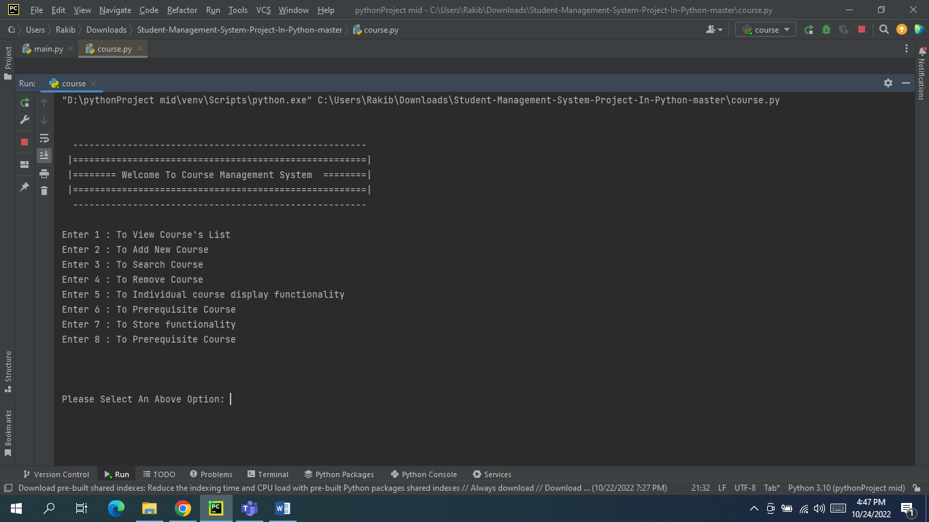

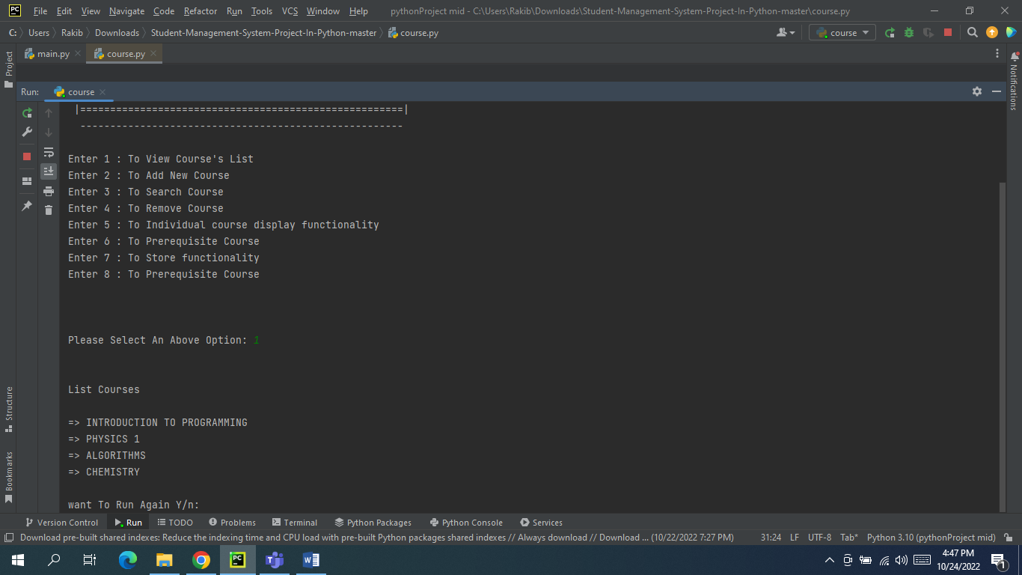

**Add New Course**

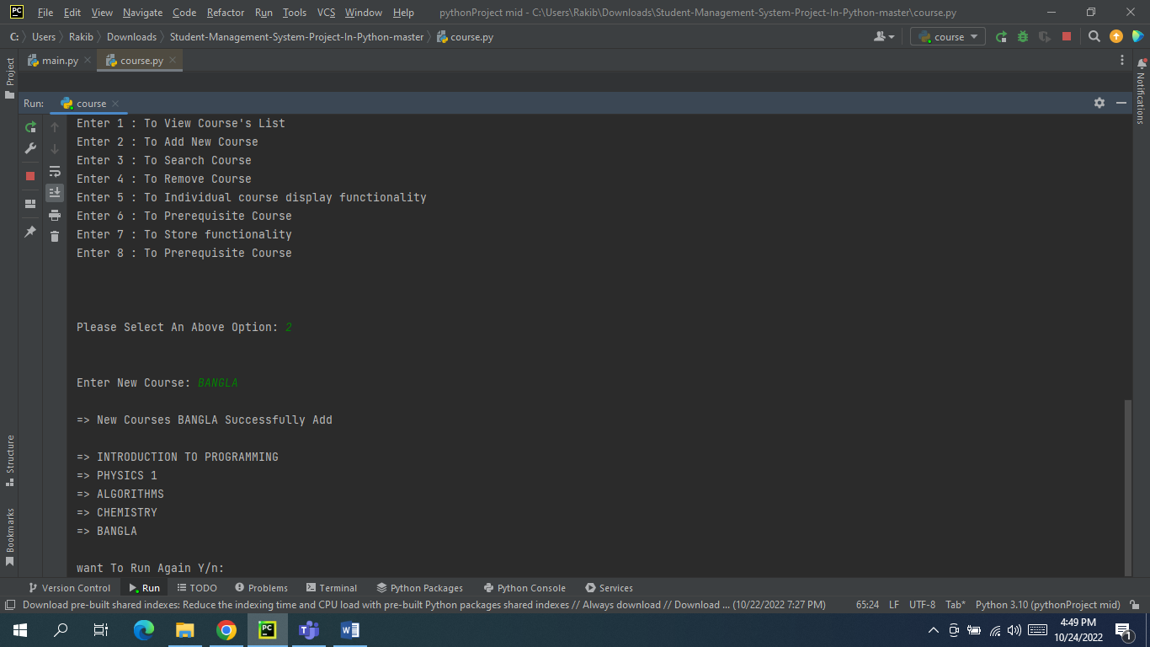

**Course Search**

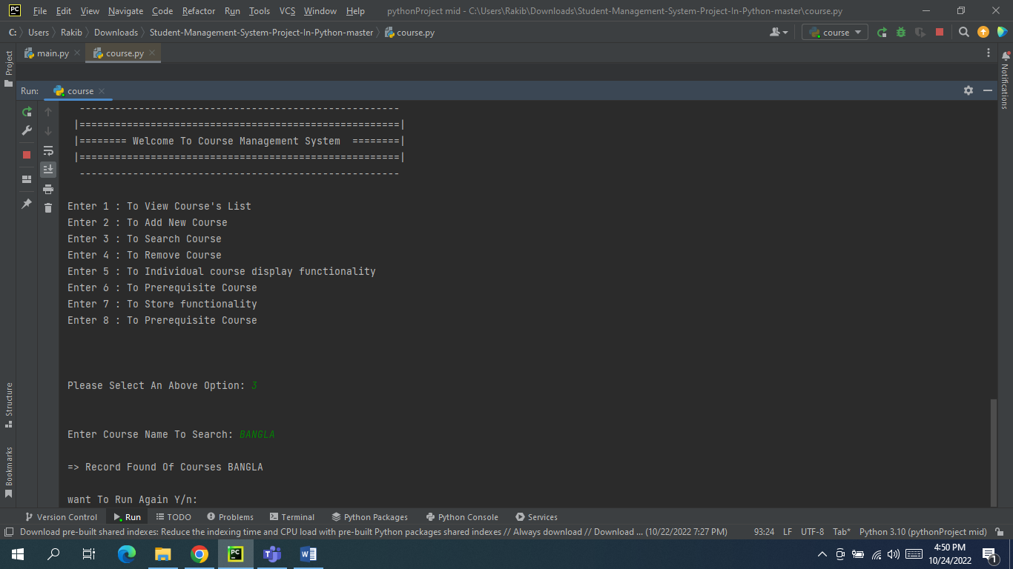

**Course Remove**

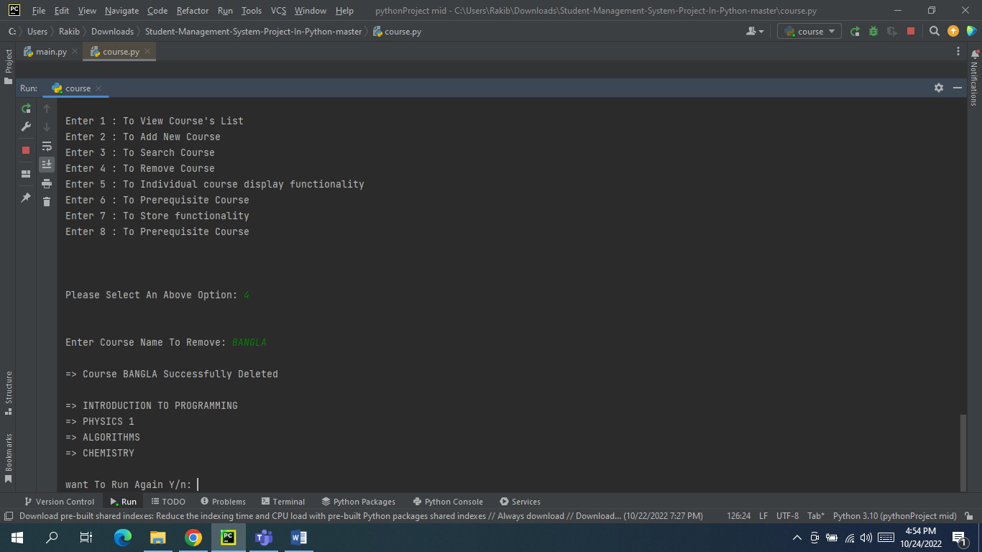

**CourseIndividual course display functionality**

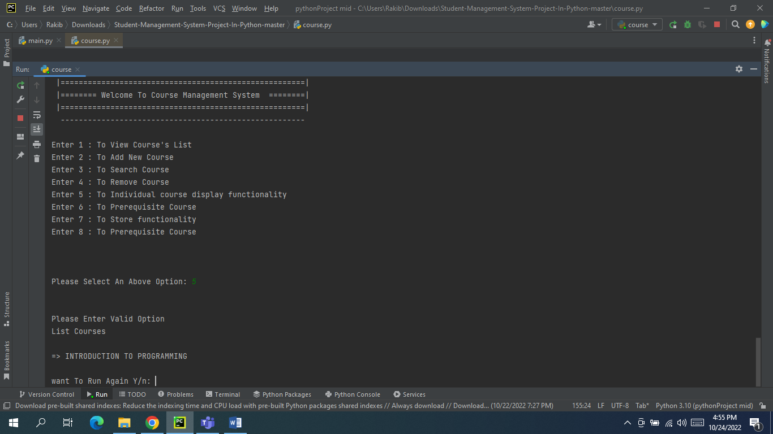

**Prerequisite Course**

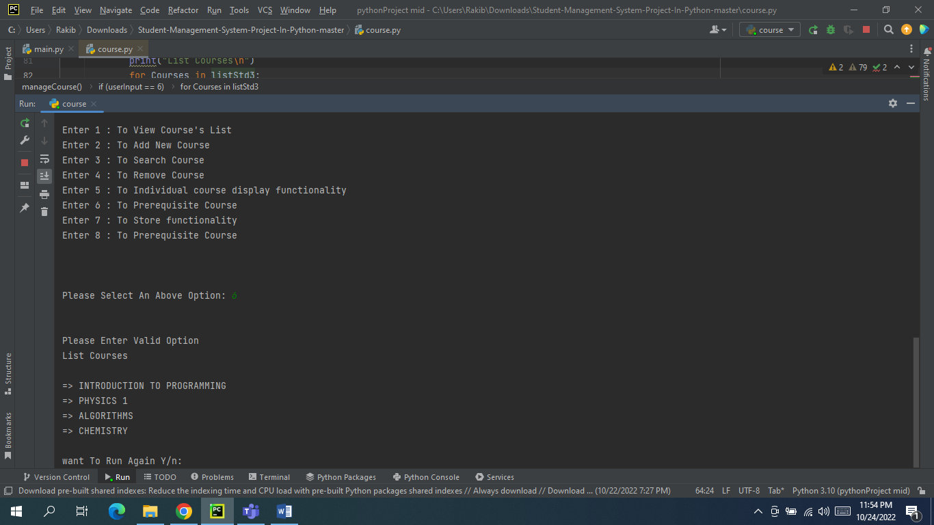

**Implementation:**

global listStd #Making ListStd As Super Global Variable1  
listStd = ["INTRODUCTION TO PROGRAMMING", "PHYSICS 1", "ALGORITHMS", "CHEMISTRY"] #List Of course  
listStd2 = ["INTRODUCTION TO PROGRAMMING"]#Individual course  
listStd3 =["INTRODUCTION TO PROGRAMMING", "PHYSICS 1", "ALGORITHMS", "CHEMISTRY"]#Prerequisite Course  
  
def manageCourse(): #Function For The Course Management System  
  
 x = "#" * 30  
 y = "=" * 28  
 #Printing Welcome Message And options For This Program  
 print("""   
  
 ------------------------------------------------------  
 |======================================================|   
 |======== Welcome To Course Management System ========|  
 |======================================================|  
 ------------------------------------------------------  
  
Enter 1 : To View Course's List   
Enter 2 : To Add New Course   
Enter 3 : To Search Course   
Enter 4 : To Remove Course  
Enter 5 : To Individual course display functionality   
Enter 6 : To Prerequisite Course   
Enter 7 : To Store functionality  
Enter 8 : To Prerequisite Course   
  
   
 """)  
  
 try: #Using Exceptions For Validation  
 userInput = int(input("Please Select An Above Option: ")) #Will Take Input From User  
 except ValueError:  
 exit("\nHy! That's Not A Number") #Error Message  
 else:  
 print("\n") #Print New Line  
  
 #Checking Using Option   
 if(userInput == 1): #This Option Will Print List Of Students  
 print("List Courses\n")  
 for Courses in listStd:  
 print("=> {}".format(Courses))  
  
 elif(userInput == 2): #This Option Will Add New Student In The List  
 newStd = input("Enter New Course: ")  
 if(newStd in listStd): #This Condition Checking The New Student Is Already In List Ur Not  
 print("\nThis Student {} Already In The Database".format(newStd)) #Error Message  
 else:   
 listStd.append(newStd)  
 print("\n=> New Courses {} Successfully Add \n".format(newStd))  
 for Courses in listStd:  
 print("=> {}".format(Courses))  
  
 elif(userInput == 3): #This Option Will Search Student From The List  
 srcStd = input("Enter Course Name To Search: ")  
 if(srcStd in listStd): #This Condition Searching The Student  
 print("\n=> Record Found Of Courses {}".format(srcStd))  
 else:  
 print("\n=> No Record Found Of Courses {}".format(srcStd)) #Error Message  
  
 elif(userInput == 4): #This Option Will Remove Student From The List  
 rmStd = input("Enter Course Name To Remove: ")  
 if(rmStd in listStd): #This Condition Removing The Student From The List   
 listStd.remove(rmStd)  
 print("\n=> Course {} Successfully Deleted \n".format(rmStd))  
 for Courses in listStd:  
 print("=> {}".format(Courses))  
 else:  
 print("\n=> No Record Found of This Course {}".format(rmStd)) #Error Message  
   
 elif(userInput < 1 or userInput > 4): #Validating User Option  
 print("Please Enter Valid Option") #Error Message  
  
  
  
  
 if (userInput == 6): # This Option Will Print List Of Students  
 print("List Courses\n")  
 for Courses in listStd3:  
 print("=> {}".format(Courses))  
  
  
  
  
  
  
manageCourse()  
  
def runAgain(): #Making Runable Problem1353  
 runAgn = input("\nwant To Run Again Y/n: ")  
 if(runAgn.lower() == 'y'):  
 if(platform.system() == "Windows"): #Checking User OS For Clearing The Screen  
 print(os.system('cls'))   
 else:  
 print(os.system('clear'))  
 manageCourse()  
 runAgain()  
 else:  
 quit(bye) #Print GoodBye Message And Exit The Program  
  
runAgain()